1. **Display Recipe Details:**

* Now for the recipe detail here(recipes-detail.component.html), there I want to output the information about the selected recipe.
* <div class="row">
* <div class="col-x2-12">
* <img src="" alt="" class="img-responsive">
* </div>
* </div>
* <div class="row">
* <div class="col-xs-12">
* <h1>Recipe Name</h1>
* </div>
* </div>
* <div class="row">
* <div class="col-xs-12">
* <div class="btn-group">
* <button
* type="button"
* class="btn btn-primary dropdown-toggle">
* Manage Recipe<span class="caret"></span>
* </button>
* <ul class="dropdown-menu"></ul>
* <li><a href="#">To Shopping List</a></li>
* <li><a href="#">Edit Recipe</a></li>
* <li><a href="#">Delete Recipe</a></li>
* </div>
* </div>
* </div>
* <div class="row">
* <div class="col-xs-12">
* Description
* </div>
* </div>
* <div class="row">
* <div class="col-xs-12">
* Ingredients
* </div>
* </div>
* So that is the recipe detail component, having all the logic inside of it which we need to display the details.
* And then having some options to go somewhere else in our app or to trigger something else in our app like editing the recipe.
* We can see the same as output in browser:

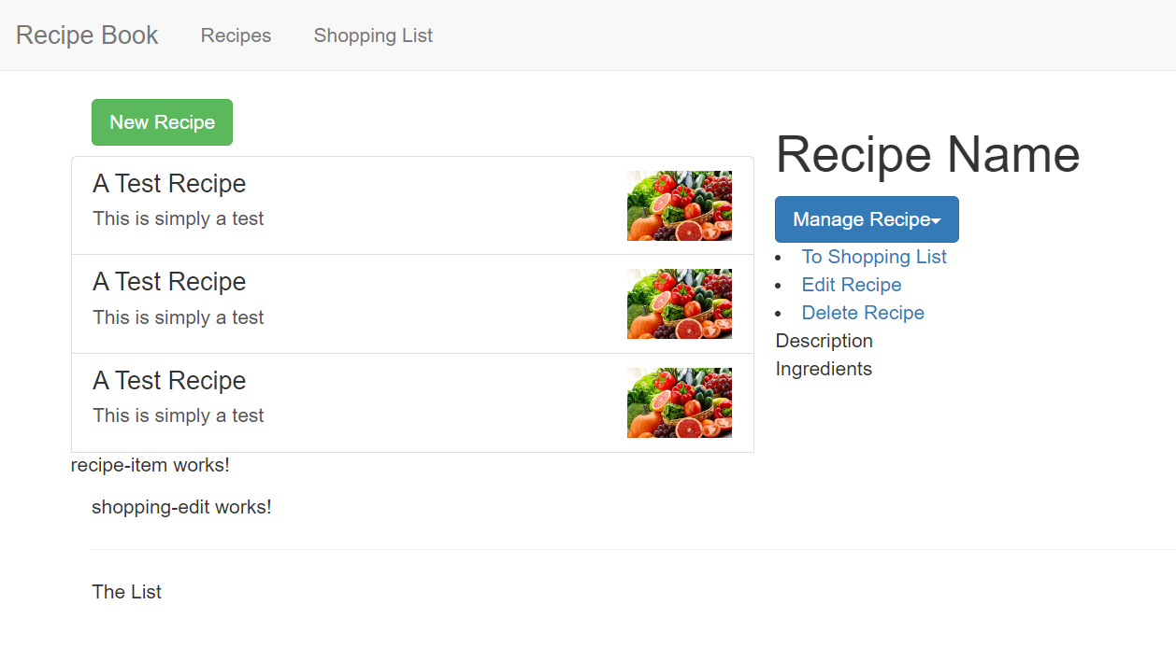

* Communicating between the two components, list and detail, is something we don't know how to do right now.
* We have the same issue in the list component
* Lets see about it in next video.